**Problem 1B)**

The following are the 6 graphs showing the 6 functions I generated (one for each function depth from 0 to 5) for the given training data:

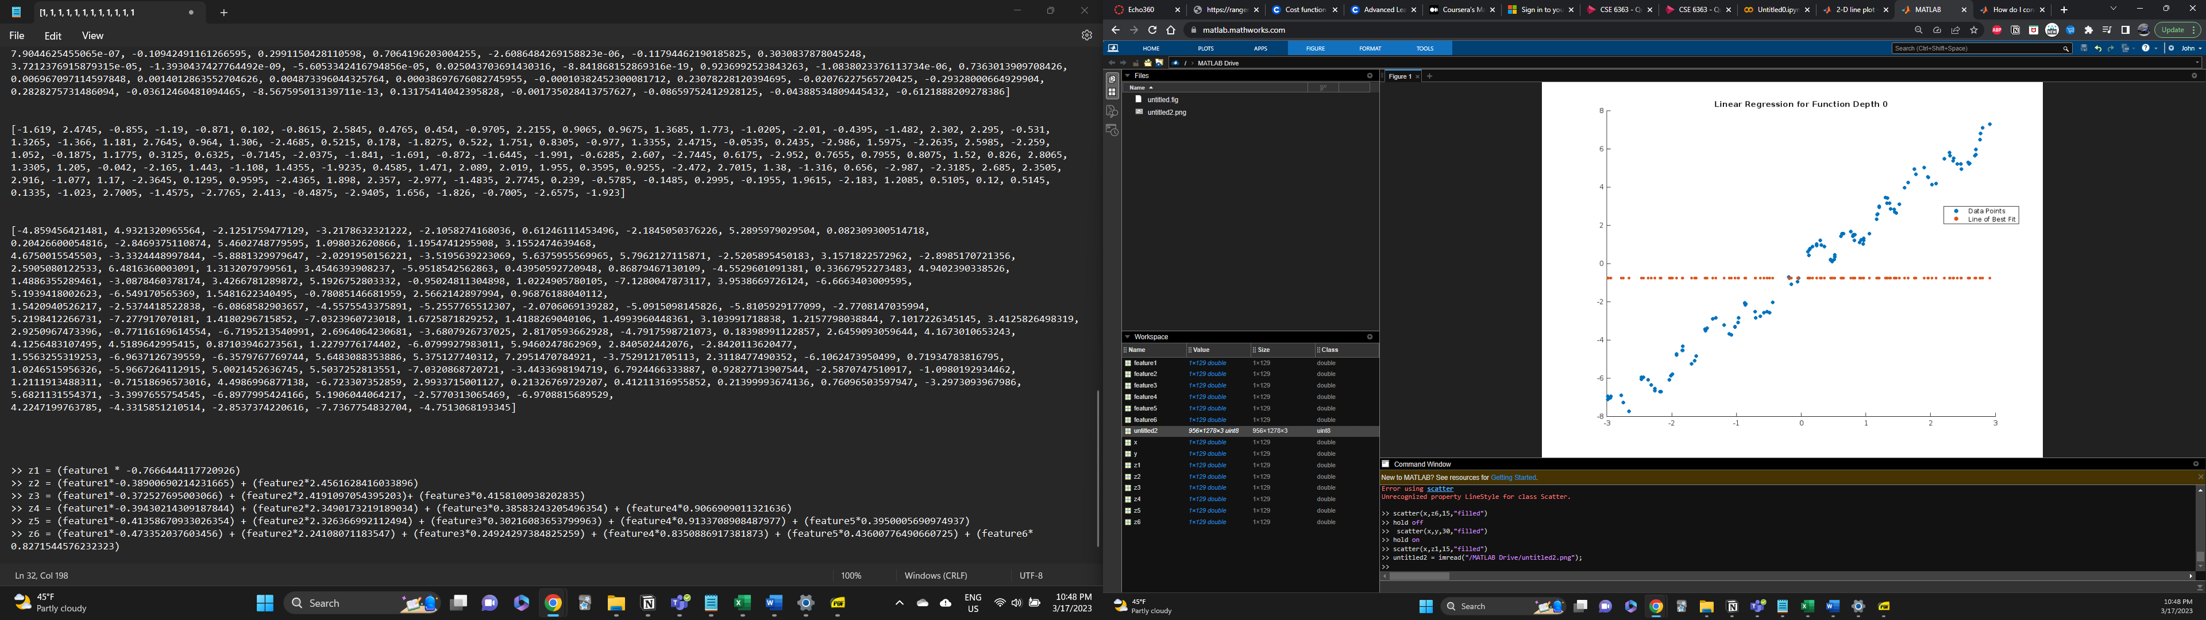

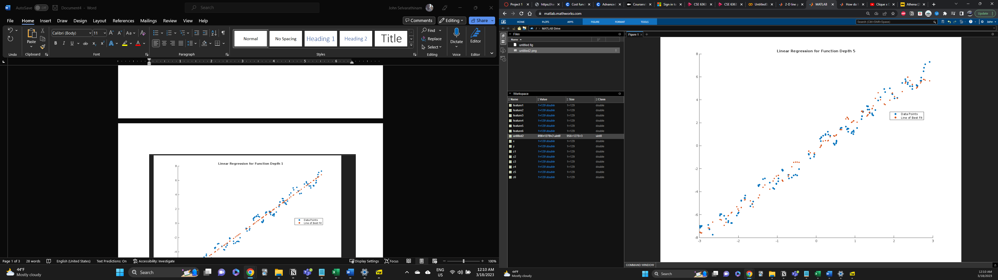

**Problem 1C)**

I used mean squared error (MSE) to calculate the difference between my predicted values and the test data points for each of the 6 function depths. They were as follows:

Function Depth 0 Error: 12.967909628705886

Function Depth 1 Error: 0.29484586716304034

Function Depth 2 Error: 0.3167162925362936

Function Depth 3 Error: 0.3196742446711267

Function Depth 4 Error: 0.5158192193230983

Function Depth 5 Error: 0.6645338788026754

Therefore, the predicted values for Function Depth 1 had the least error out of all 6 function depths. Looking at the graphs from Part B of this question this makes sense visually as the predicted values of the regression don’t seem too far away from the actual data points. Therefore, I would consider Function Depth 1 the best predictor because it matched the trend of the data the best, had the least error, and didn’t appear to be overfitted at all.

I would consider Function Depths 4 and especially 5 to suffer from overfitting. This can be seen visually in the graphs from Part B of this problem as well, where the predicted values appear to try to follow the data points too closely and end up not really following the general trend of the data points.